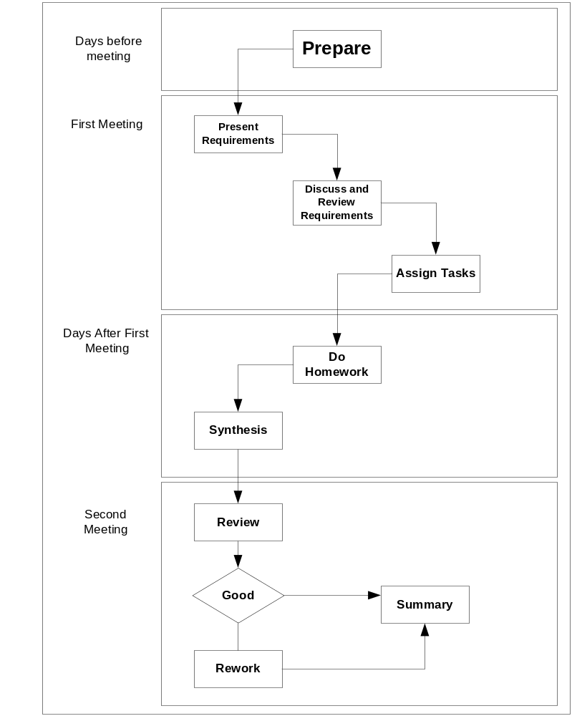
Steps | Description
Prepare | In first step, team member whom is assigned task to analysis team assignment title will preview problems in assignment.  Have to compose and delivery objects of meeting, problems need to discuss and tasks will give to each member in assignment.
Present requirement | Team member whom is assigned task to analysis team assignment title have to present the objects of meeting, problems and tasks to do for his/her team.
Discuss and review | Everybody in team will discuss the giving problems in previous step. Review objects of team assignment and tasks to do.  Everybody will modify objects and tasks to do together in this meeting after discussion.
Assisgn tasks | Team leader will assign works for each people.
Do homework | Team members will complete their works at home and send them to sub-leader.
Synthesis | Sub-leader will collect and integrated, preview final document and prepare to present.
Review | In this meeting, everybody will review and ensure assignment was finished. Documents were completed and check spelling errors.
Rework | If detect problems in documents, everybody will discuss and solve it in this meeting.
Summary | Team leader collect effort logs of people, get lessons learned together and improve process for next assignment.

